Exploratory Play Activities for Early Years at Home

Fine motor activities
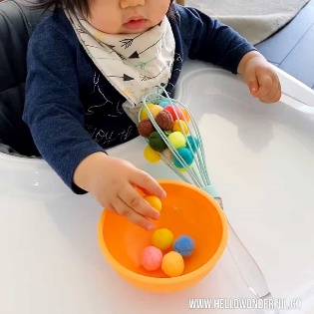  Using pom poms child to take them out of the bowl and push them into a whisk. | 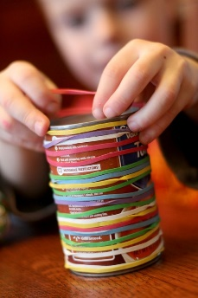  Use elastic bands and place on a tin to strengthen their finger muscles.
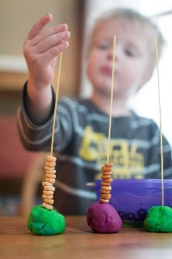  Use spaghetti in playdoh to thread on cereal. | 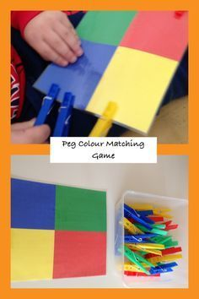  Peg on matching colours.
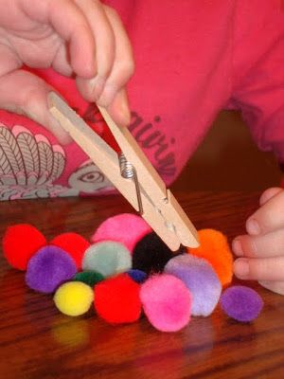  Use a peg to pick up pom poms. | 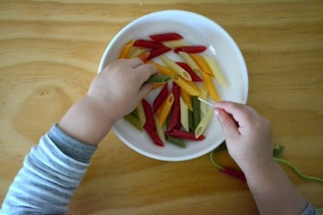  Use pasta to thread onto string.  Add food colouring to make the pasta fun colours!

Sensory play
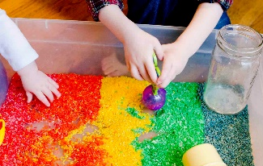  Rainbow rice.  Use food colouring and a small amount of vinegar to soak the rice in. Then leave to dry or put on a low heat in the oven. | 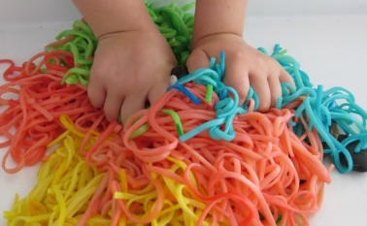  Coloured Spaghetti  Add different food colouring to spaghetti for colourful fun.
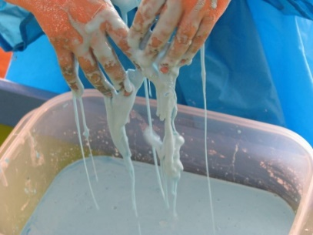  Corn flour play  Mix cornflour with water to create a fun, gloopy sensory experience. | 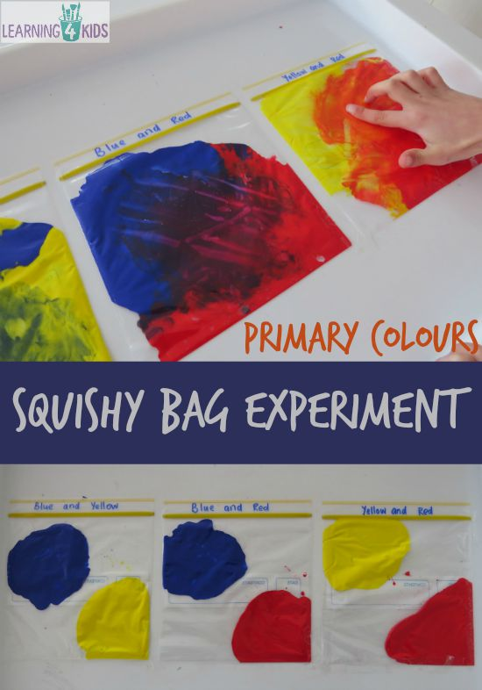  Colour mixing.  Put coloured paint in clear plastic bag and seal shut. Children can then mix the paint without touching it to see what happens.
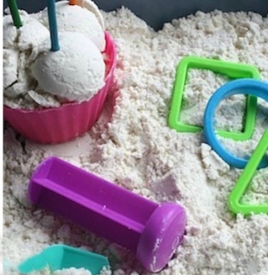  Cloud Dough 1  1 cup (13 tablespoons) flour mixed with 120mm of oil. Mix well.  You can add food colouring to make different colours or essential oil to give it a nice smell. | 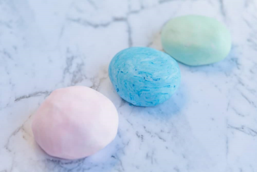  Cloud dough 2  Mix 2 parts cornflour with 1-part hair conditioner.  Add a few drops of food colouring for a soft playdough

Anticipation activities
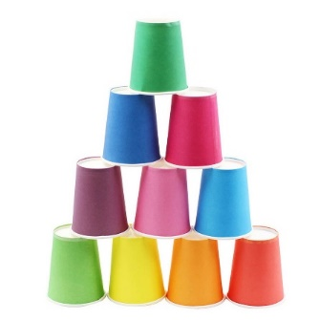  Stacking cups.  Use paper cups to build up a pyramid. Say ‘ready, steady’ then knock it down on go or when your child indicates they want you to ‘go | 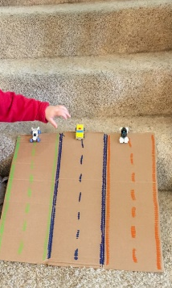  Cars on a ramp.  Place the car at the top of a ramp or slide. ‘ready, steady’ then push the car down on go. Wait for your child to indicate they want you to go.
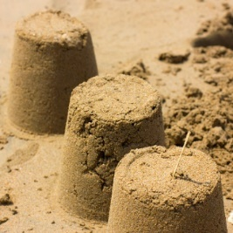  Sandcastles.  Using sand or flour make small sandcastles. ‘ready, steady…..’ and flatten them with your hands | 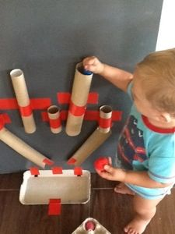  Ball Run  Use tubes to create a ball run. Encourage your child to say ‘go’ before dropping the ball.

Creative activities.
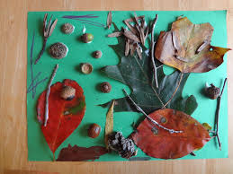  Nature Pictures.  Collect leaves/twigs and any bits you find on a walk and create a picture. | 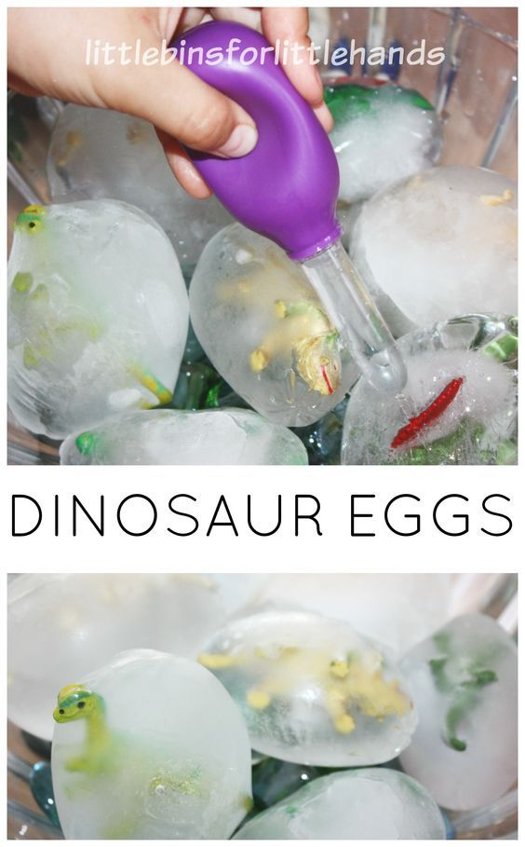  Frozen dinosaur eggs.  Freeze toy dinosaurs in water (you can use a water balloon or lolly maker mould.) Use spoons/tools and hands to see if they can get the dinosaur out.
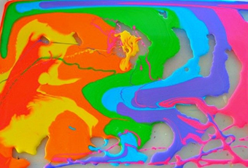
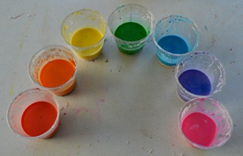
Rainbow painting
Add water to cornflour until it is a runny consistency.
Add drops of food colouring or paint.
Use hands or different tools to move the mixture around in a tray.

Ice painting.  Mix paint with a small amount of water and freeze with a cocktail stick. Use the ice paint to create fun pictures and see what happens as they start to melt.  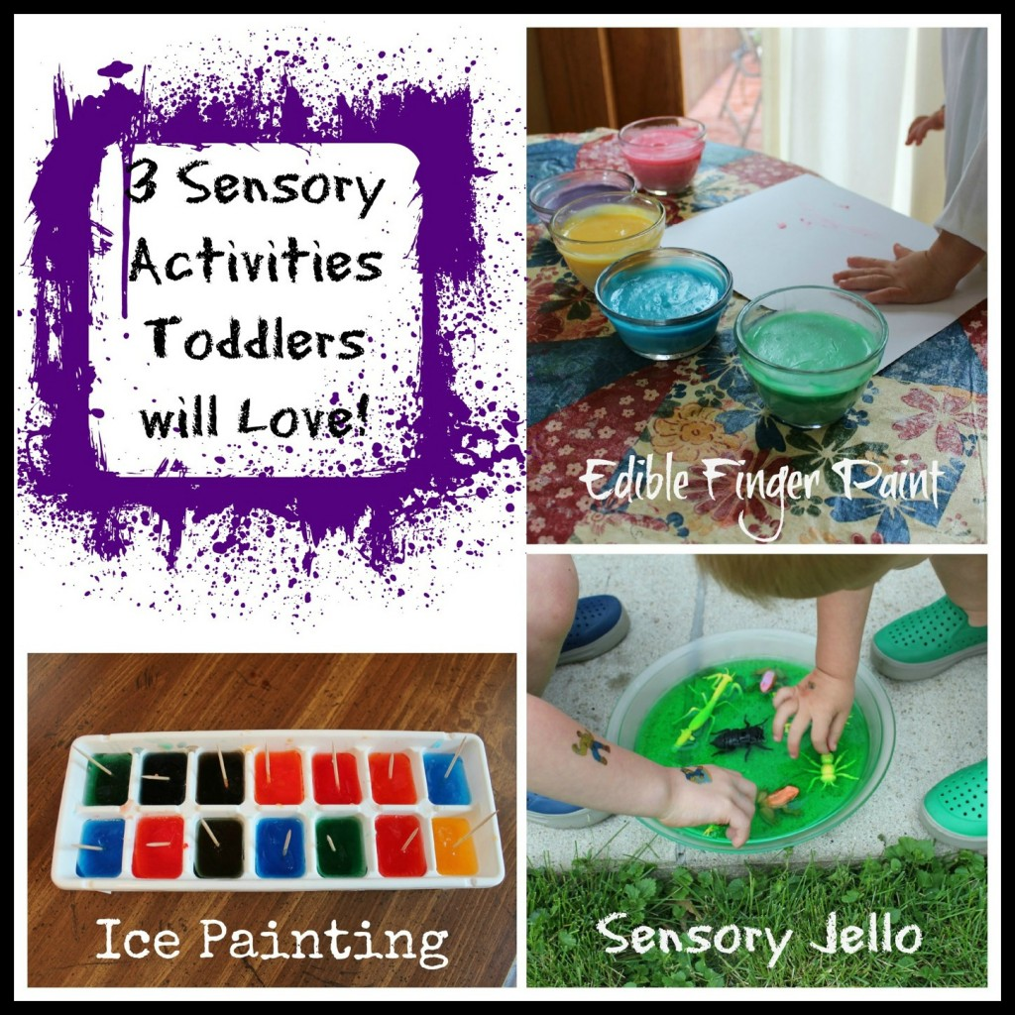 | Outside music  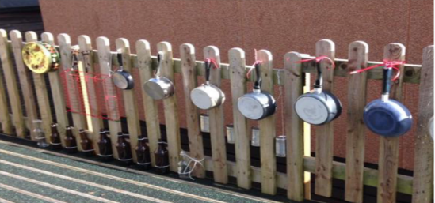  Use old pots and pans/buckets etc. Hang them up to create a musical wall.
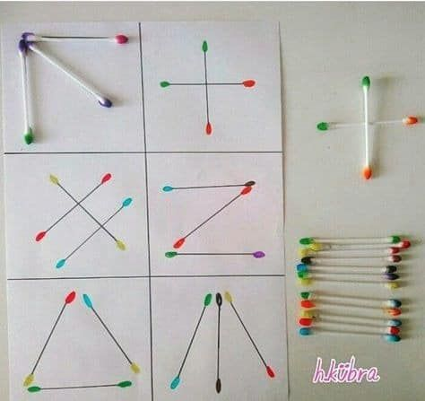  Matching activity  Colour in cotton buds to match on to pre drawn pictures. Create patterns and encourage colour matching. | 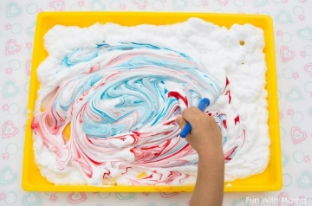  Shaving foam painting.  Spray shaving foam in a tray.  Add a small amount of paint. Use a paint  brush or use fingers to be creative.

Other play and early learning activities
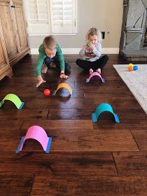  Indoor croquet  Create tunnels using card and roll a ball through them. | 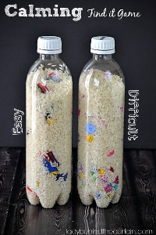  I Spy game  Fill a bottle with rice and small objects. See how many you can find.
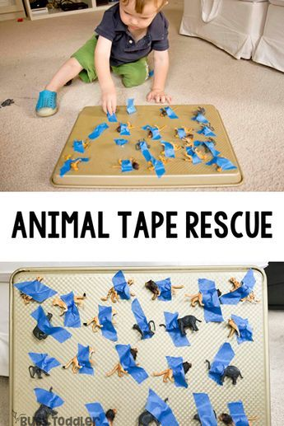  Animal Rescue  Tape down some animals and see if your child can help rescue them. | 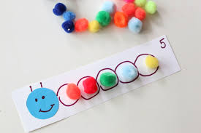  Pompom caterpillars  Can be used to support fine motor, colour matching, colour sequencing or number skills.  Colour matching – colour in each section of the caterpillar and get your child to match with the matching coloured pompom.  Sequencing - make a coloured caterpillar for your child to copy or continue the colour sequence.
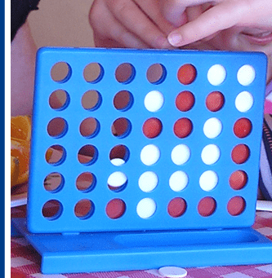  Turn taking  Encourage turn taking by playing games. Use visuals to support whose turn it is. | 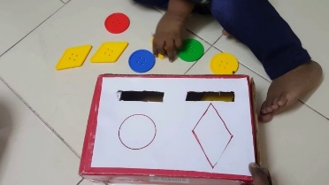  Posting activities.  Create your own posting box with shapes/numbers/colours or with just one hole for younger children.
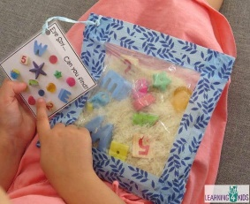  Eye spy sensory bag  Fill a bag with dry rice and some treasures  For your child to find. | 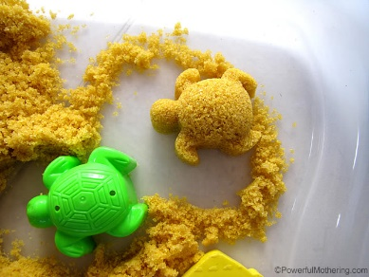  Moon sand  1 cup brown sugar  1 cup cornflour  5 tablespoons oil
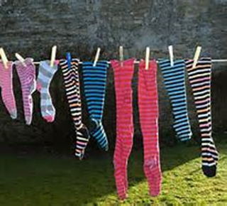
Match the socks
Place socks of different colours and patterns around the room. Can your child find the pairs, finding ones that are the same.

