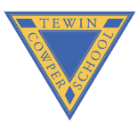
Year 6 Optional Topic Homework - Autumn Term
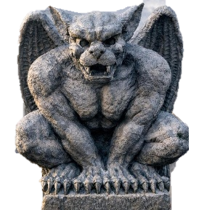
Activities linked to our topic
  Maths:  .  Times tables are one of the key skills we need to succeed in Year 6. Use this term to master your times tables and GO GREEN on TTRockstars. |   History:  Visit a World War 2 museum – such as the amazing “Forties Experience” at The Lincolnsfields Children's Centre in Bushey – and explore what life was like during World War 2 through the stories of evacuees and people who lived during the Blitz. | English:  .  Sketch a Gargoyle either from a photo or an actual statue. Make sure to include all the key and relevant details.
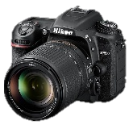  Art:  Create a photomontage with photos you have at home based around a theme. Collage them carefully for effect. | 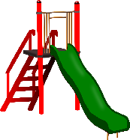  D&T:  Visit a playground and think about how it was designed and built. What features are there to cater for different ages? How has it been made safe? | 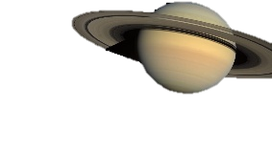  English:  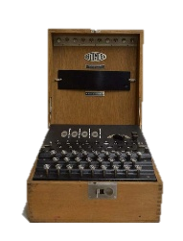  Explore the solar system through an interactive planetarium app or a visit to an actual planetarium. What kind of information do scientists need to know about planets?
  Geography:  Explore what population is by exploring the populations of countries that you are interested in. Why do you think they are so high or low? |   Science:  Explore the Linnaean system by visiting the Natural History Museums in London or Tring – when you visit, look at the animals and how they have been sorted. What features do they share? How were they classified? | Computing:  Visit Bletchley Park and learn more about the secret world of World War 2 code breaking. Investigate Alan Turing and how their work helped win World War 2. Can you create your own coded messages?
Books linked to our topic
Wonder by RJ Polaco
Groosham Grange by Anthony Horroritz
The Watertower and Beneath the Surface by Gary Crews
Night of the Gargoyles by Eve Bunting
Wisp: A Story of Hope by Zana Fraillon
Talking History by Joan Haig

